1406. Stone Game III

Youtube Link:[ https://youtu.be/HsLG5QW9CFQ?si=7KfTetlTVDsyq2Xt ]

Question : [ https://leetcode.com/problems/stone-game-iii/submissions/2092219969/?envType=daily-question&envId=2026-08-03 ]

Ans :
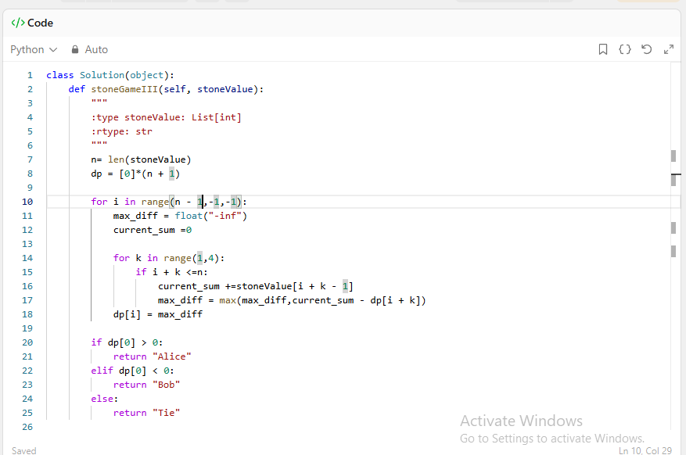

OUTPUT

